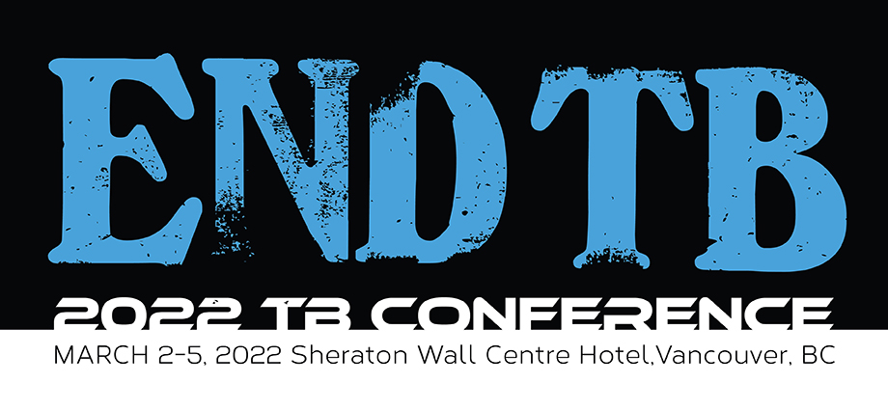

CALL FOR LATE-BREAKER ABSTRACTS
Deadline for Submission: December 1, 2021

We welcome the submission of abstracts for poster and oral presentations of research on all aspects of tuberculosis prevention and care, including epidemiologic, clinical, basic science, nursing, social, behavioural, psychosocial and educational studies, as well as outcomes of program initiatives. We also welcome abstracts on topics other than tuberculosis, including COVID-19 and smoking cessation. Abstracts must be submitted in accordance with these guidelines.

Oral and Poster Presentations
- You may request 1) poster presentation only, or 2) possible invitation for oral presentation according to score. (Note: The decision to extend an invitation for an oral presentation is based primarily on the score an abstract earns and its contributions of new programmatic or scientific knowledge relating to the plenary agenda.)
- All abstracts submitted will be reviewed.
- The highest-ranked abstracts will be considered for oral presentation and others for poster presentation.
- Abstracts of limited quality and those lacking results will not be accepted.
- At least one author of the abstract must register for the conference by January 6, 2022 and attend the conference.

Abstract Content
- Abstracts may be written in English, French or Spanish however, we encourage Posters to be in English.
- Abstracts must be:
    - maximum of 250 words, excluding title, headings, and authors’ names and affiliations
- The body of the abstract should contain the following sections (Note: section names should be included in the abstract, and written in all CAPITAL LETTERS):
  - TITLE
  - AUTHORS (last names and initials only, omit degrees), institutions, city, country (omit street address and zip/postal code); underline the name of presenting author
  - BACKGROUND
  - DESIGN/METHODS or INTERVENTION/RESPONSE
  - RESULTS (Give both numbers and proportions where applicable)
  - CONCLUSION

Abstracts may involve scientific research or public health practice, as described by The Union:
Category 1: Scientific research
It is recommended that the abstracts in Category 1 be organized using the following sections:
- Background: State study objectives, study question or a description of the challenge addressed by the research.
- Design/Methods: State the setting, methods, desired outcomes, procedures and techniques used to collect and analyze information. Include a description of participants, procedures, measures and appropriate statistical analyses.
- Results: Present specific findings to date.
- Conclusion and recommendations: State the implications of the results and key recommendations. Present specific findings on how the research addressed the study, question or challenge. Highlight opportunities for future research as well as implications for further research for TB prevention and care programs.

Category 2: Public health practice /education and training
It is recommended that the abstracts in Category 2 be organized using the following sections (if an abstract cannot address these sections, it is likely not eligible for submission):
- Background and reason for implementation or problem being addressed: identify the context and the specific challenges to program implementation. Describe the activity, program or policy by which the issue was addressed. Describe target populations, geographic sites/locations and scale and type of activity or service.
- Intervention or response: how was the challenge overcome? Detail the methods, activities and implementation steps used to overcome the challenge. Describe the methods, procedures and techniques used to collect and analyze information that informed your conclusions. Identify the course of action used to address program implementation issues.
- Results and lessons learned: describe the results and impact of the project. Explain the potential application or benefit to other programs. Describe what worked and what did not work and the evidence that led to this determination.
- Conclusions and key recommendations: state the implications of the effective public health practice and key recommendations. Highlight opportunities for future program practice, as well as implications for other programs or settings.

Scoring Criteria
Quality of writing 0-5 points
Originality 0-5 points
Methods (suitability, validity) 0-5 points
Relevance of findings for TB prevention and care 0-5 points Total: 20 points

Abstracts that Do Not Adhere to The Required Format and Word Limit Will Be Excluded from Consideration.

For Abstract Submitters New to TB Care and Prevention (those who have been in the field < 5 years) or if English is your second language and you are submitting an abstract in English: Check here if you would like to receive feedback on your abstract with the option to revise and resubmit within 2 weeks. Please note that resubmission of a revised abstract does not guarantee acceptance.

Submission
Electronic submission is possible either by email to tbconference@bc.lung.ca or through the online submission portal accessible at https://www.jotform.com/lungassociation/2021abstracts.

OPTIONAL MENTORING for Abstract Submitters New to TB Care and Prevention
All junior conference attendees (those with < 5 years’ experience) can choose to be matched with a senior mentor who will meet with you prior or during the conference to offer professional guidance. This is a unique opportunity to seek career advice from an established expert in your field of interest. Membership to The Union-NAR is mandatory for participation in the mentoring program. Please contact Menn Biagtan at biagtan@bc.lung.ca for more information.

Top Scoring abstract award– will be awarded to the abstract with the highest score based on the scoring system and submitted by a student, trainee, fellow, or a junior professional (with < 5 years of professional experience in TB Care and Prevention; includes nurses, physicians, public health professionals, researchers, etc.)

Notification

Use of Non-stigmatizing language:
The Union-NAR is committed to promoting patient-centered, non-stigmatizing language in conference abstracts and presentations and therefore requests that you follow the guidance laid out in the Stop TB Partnership’s publication: Suggested Language and Usage for Tuberculosis (TB) Care, Communications and Publications.

Deadline for Submission: December 1, 2021

Notification
- We will notify the submitting author of acceptance for oral (if requested) or poster presentation or rejection no later than December 17, 2021.
- Abstracts may be accepted as submitted, or conditionally. If accepted conditionally, we will contact you with instructions for revisions needed, or to provide assistance. If you may need assistance, we encourage you to submit your abstract early (at least 2 weeks before the deadline) and request assistance.
- All accepted abstracts will be published in the meeting proceedings.
- Please note: If the abstract is accepted for oral presentation, authors will be required to submit presentations for review by February 9, 2022. Oral presentations will be limited to 7 minutes in length, with 3 minutes for discussion. Presenters of abstracts selected for oral presentation must also sign a conflict of interest disclosure form. This form will be provided to the authors and must be submitted along with the presentation.

Submit abstracts to: tbconference@bc.lung.ca

For Additional information:

Menn Biagtan, MD, MPH
Conference Secretariat
T: 604.731.5864/F: 604.731.5810

E-mail: biagtan@bc.lung.ca

