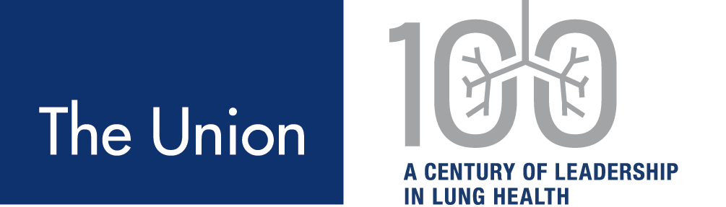

August 19, 2021

Re: Call for Award Nomination Lifetime Achievement/Service Awards

Dear Colleague,
The North America Region of The Union is calling for Nominations for its Awards. Each year, at the time of our annual meeting we recognize the valuable contributions of our colleagues to tuberculosis (TB) care and prevention. We are happy to announce that we will be returning to an in-person meeting, March 2-5, 2022, in Vancouver, BC Canada.
The Lifetime Service Award is given to individuals who have made a significant contribution to the practice of TB. This award may be given annually. Recipients may include administrators, educators, and public health advisors, as well as nurses and physicians. Prior recipients are listed on the following page.
The Lifetime Achievement Award is given to an individual who has made outstanding contributions to the field of TB over a lifetime through mentoring or research. This award may be given annually. Prior recipients are listed on the following page.
If you are a member of The Union-North America Region in good standing, you may nominate a candidate by filling out the attached form. The nominee need not be a NAR member but must have made his/her contributions in the NAR region – United States, Canada, or the English, French or Dutch speaking regions of the Caribbean and the Americas.
Nominees are reviewed by the Nominating Committee. Eligible candidates are then presented to the NAR Executive Committee for final selection. Please submit all nominations to Menn Biagtan at biagtan@bc.lung.ca by November 16th by using the attached forms.
Thank you for your assistance in bringing forward deserving individuals for this recognition.

Yours truly,
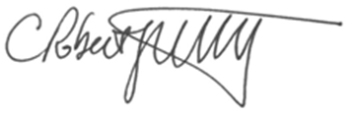

C. Robert Horsburgh, Jr. MD Lisa Chen, MD
Co-chair, Nominating Committee Co-chair, Nominating Committee

Recipients of the Lifetime Achievement Award
 | Year
Dr. Lee Reichman | 2000
Dr. Earl Hershfield | 2001
Dr. Anne Fanning | 2004
Dr. George Comstock | 2006
Dr. Jacques Grosset | 2008
Dr. Leonid Heifets | 2009
Dr. William Pape | 2010
Dr. Phil Hopewell | 2011
Dr. Don Enarson/ Ms. Sue Etkind | 2012
Dr. C. Fordham von Reyn/ Dr. Ed Ellis | 2013
Dr. Ken Castro | 2014
Dr. C. Robert Horsburgh, Jr. | 2015
Dr. Michael Iseman | 2016
Dr. Wanda Walton | 2016
Dr. Richard O'Brien | 2018
Dr. Andrew Vernon | 2019
Dr. Richard Long | 2020
Dr. Richard Chaisson/ Dr. Jeffrey Starke | 2021
Recipients of the Lifetime Service Award
Dr. Nancy Breton/ Sue Etkind/Rose Pray/ Kim Field and Jerry Lama | 2006
Ms. Kathy Hursen | 2007
Dr. Ed Ellis, Dr. Richard Wing, Dr. Kathy Moser, Elaine Benjamin | 2008
Dr. Ed Nardell, Dr. Richard Long and Marlene Francis | 2009
Dr. Dick Menzies/ Joy Marshall, | 2010
Dr. Kevin Elwood/Dr. Dick Menzies | 2011
Dr. Margarita Elsa Villarino, Dr. Reynard McDonald/Dr. Charles Crane/ Dr. Vernon Hoeppner | 2013
Dr. Barbara Seaworth, Dr. Bob Cowie, and Ms. Karen Martinek | 2014
Dr. Terry-Nan Tannenbaum, Shelley Dean, Charles Wallace; Eileen Napolitano | 2015
Dr. Dennis Kunimoto | 2016
Mr. Scott McDonald | 2017
Dr. Jane Carter and Ms. Ellen Murray | 2020

