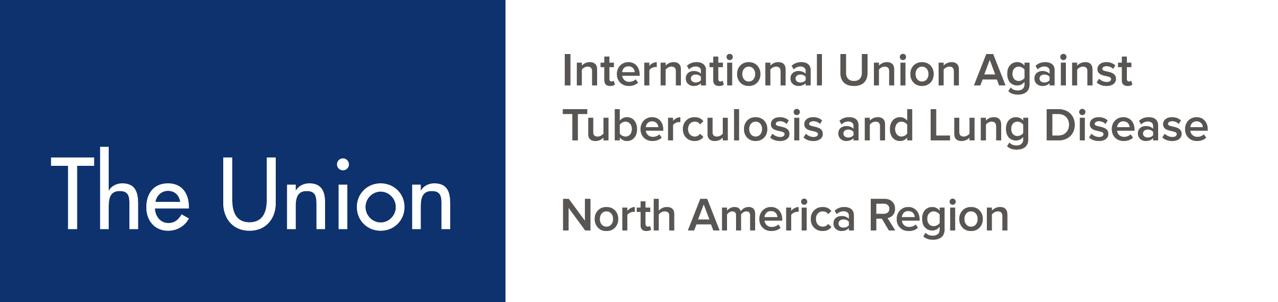

CALL FOR ABSTRACTS & CHALLENGING CASES

Deadline for Submissions: September 30, 2025

A. ABSTRACT SUBMISSION
We welcome the submission of abstracts for poster and oral presentations containing research on all aspects of tuberculosis prevention and care, including epidemiological, clinical, basic science, nursing, social, behavioural, psychosocial, and educational studies, as well as outcomes of program initiatives. We also welcome abstracts on other respiratory pathogens and smoking cessation. Abstracts must be submitted in accordance with these guidelines.

Oral and Poster Presentations
- You may request:
  - Poster presentation only
OR
  - Possible invitation for oral presentation according to score. (Note: The decision to extend an invitation for an oral presentation is based primarily on the score an abstract earns and its contributions of new programmatic or scientific knowledge relating to the plenary agenda.)
- All abstracts submitted will be reviewed.
- The highest-ranked abstracts will be considered for oral presentation and others for poster presentation.
- Abstracts of limited quality and those lacking results will not be accepted.
- At least one author of the abstract must register for the conference by December 5, 2025, and attend the conference.

Abstract Content
- Abstracts may be written in English, French, or Spanish; however, we encourage posters to be in English.
- Abstracts must be a maximum of 250 words, excluding title, headings, and authors’ names and affiliations
- The body of the abstract should contain the following sections (Note: section names should be included in the abstract, and written in all CAPITAL LETTERS):
  - TITLE
  - AUTHORS (last names and initials only, omit degrees), institutions, city, country (omit street address and zip/postal code); underline the name of presenting author
  - BACKGROUND
  - DESIGN/METHODS or INTERVENTION/RESPONSE
  - RESULTS (Give both numbers and proportions where applicable)
  - CONCLUSION

Abstracts may involve scientific research or public health practice, as described by The Union:
Category 1: Scientific research
It is recommended that the abstracts in Category 1 be organized using the following sections:
- Background: State study objectives, study questions, or a description of the challenge addressed by the research.
- Design/Methods: State the setting, methods, desired outcomes, procedures, and techniques used to collect and analyze information. Include a description of participants, procedures, measures, and appropriate statistical analyses.
- Results: Present specific findings to date.
- Conclusion: State the implications of the results and key recommendations. Present specific findings on how the research addressed the study, question, or challenge. Highlight opportunities for future research as well as implications for further research for TB prevention and care programs.

Category 2: Public health practice/education and training
It is recommended that the abstracts in Category 2 be organized using the following sections (if an abstract cannot address these sections, it is not eligible for submission):
- Background: What is the reason for implementation? What is the problem being addressed? Identify the context and the specific challenges to program implementation. Describe the activity, program, or policy by which the issue was addressed. Describe target populations, geographic sites/locations and scale and type of activity or service.
- Intervention/Response: How was the challenge overcome? Detail the methods, activities and implementation steps used to overcome the challenge. Describe the methods, procedures and techniques used to collect and analyze information that informed your conclusions. Identify the course of action used to address program implementation issues.
- Results: What are the lessons learned? Describe the results and impact of the project. Explain the potential application or benefit to other programs. Describe what worked and what did not work and the evidence that led to this determination.
- Conclusions: State the implications of the effective public health practice and key recommendations. Highlight opportunities for future program practice, as well as implications for other programs or settings.

Scoring Criteria
Originality 5 points
Clarity of the message 5 points
Results/impacts 5 points
Methods/Intervention or response 5 points
Relevance Relevance 5 points Total : 25 points
Top Scoring Abstract Award– This award will be given to the abstract with the highest score based on the scoring system and submitted by a student, trainee, fellow, or a junior professional (with < 5 years of professional experience in TB Care and Prevention). This includes nurses, physicians, public health professionals, researchers, etc.

Abstracts that Do Not Adhere to The Required Format and Word Limit Will Be Excluded from Consideration.

For Abstract Submitters New to TB Care and Prevention (those who have been in the field < 5 years) or if English is your second language and you are submitting an abstract in English: Check here if you would like to receive feedback on your abstract with the option to revise and resubmit within 2 weeks. Please note that resubmission of a revised abstract does not guarantee acceptance.

Deadline for submission: September 30, 2025.
To submit your abstract(s), please click here.

B. Challenging Cases:

New this year is an earlier call and change in format for “Challenging Cases”. We are inviting patient cases that cover a broad range of topics including diagnosis, treatment, case management, transmission/contact investigation etc. Cases that are on-going dilemmas may also be submitted. Successful cases will be asked to present it as a poster in person and some cases will be additionally selected for oral case presentation.

Submission:

To submit challenging case(s) please Click here.

Use of Non-stigmatizing language:
The Union-NAR is committed to promoting patient-centered, non-stigmatizing language in conference abstracts and presentations, and therefore requests that you follow the guidance laid out in the Stop TB Partnership’s publication: Suggested Language and Usage for Tuberculosis (TB) Care, Communications and Publications.

Deadline for Submission:

Notification
- We will notify the submitting author of acceptance for oral (if requested) or poster presentation or rejection no later than November 3, 2025.
- Abstracts may be accepted immediately, or conditionally. If accepted conditionally, we will contact you with instructions for revisions needed, or to provide assistance. If you may need assistance, we encourage you to submit your abstract early (at least 2 weeks before the deadline) and request assistance.
- All accepted abstracts will be published in the meeting proceedings.
- Please note: If the abstract is accepted for oral presentation, authors will be required to submit presentations for review by February 12, 2026. Oral presentations will be limited to 7 minutes in length, with 3 minutes for discussion. Presenters of abstracts selected for oral presentation must also sign a conflict-of-interest disclosure form. This form will be provided to the authors and must be submitted along with the presentation.

For inquiries regarding abstract submission contact:
Menn Biagtan: biagtan@bclung.ca
Matthew Wong: mwong@bclung.ca

